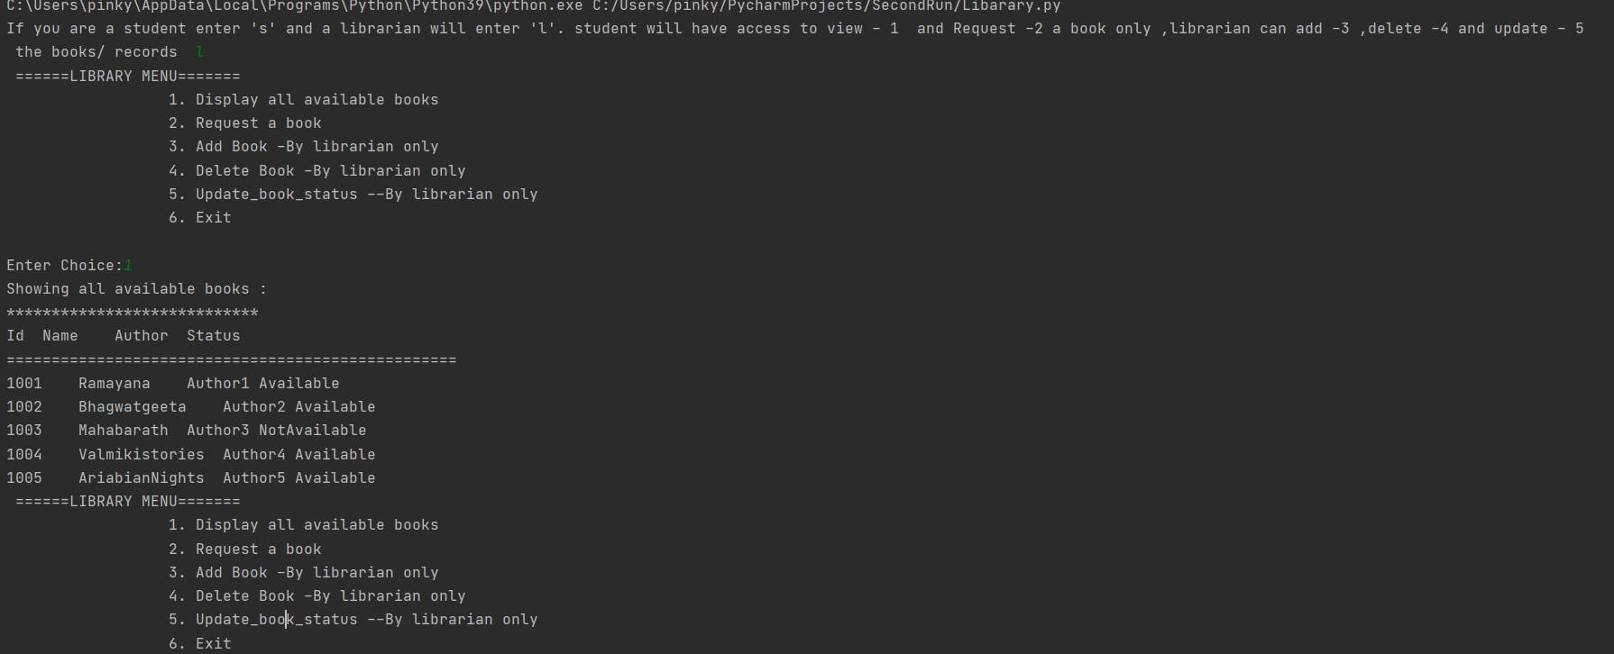

First option is asking if the person is a librarian or a student , lets go by librarian –l for now

On choosing option 1 : displaying books

Its lists down all the books , and then again the main menu

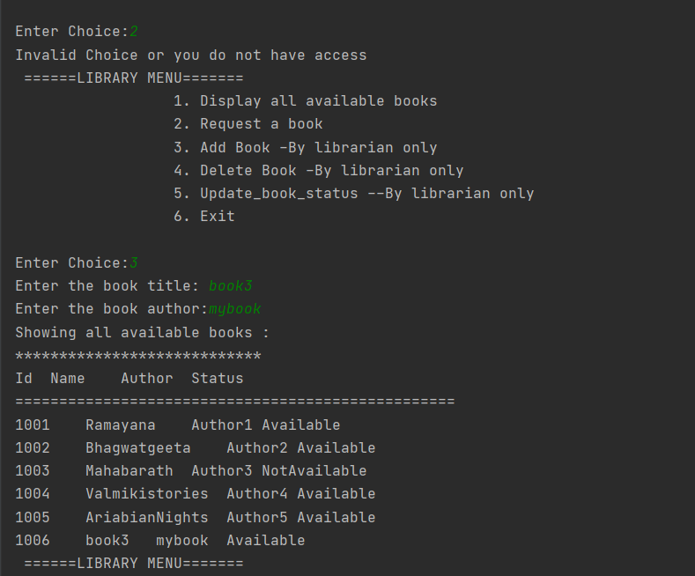

On choosing option 2 – requesting a book by a librarian we got an error message as librarian do not have access to issue a book .

Now the librarian chooses option 3 , to add a record ,he we asked for the name and the author only , the id will be calculated by us , ensuring it’s a primary key , and since the book is being added it will be in available status only

The screen shot shows the list after addition

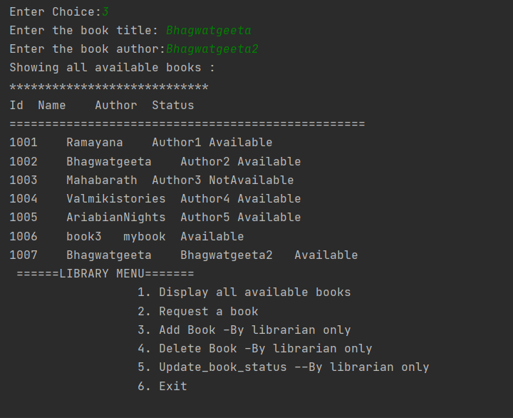

Now lets see if we add the same book ,it will allow to add the book with same name , but different key / ID and we will always have same book names with different author , so this will work fine

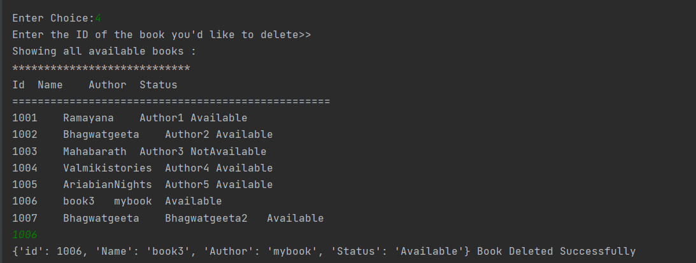first it will show all the available books , from which we can choose the ID , this shows the deletion process, and an appropriate message is sent out after deletion

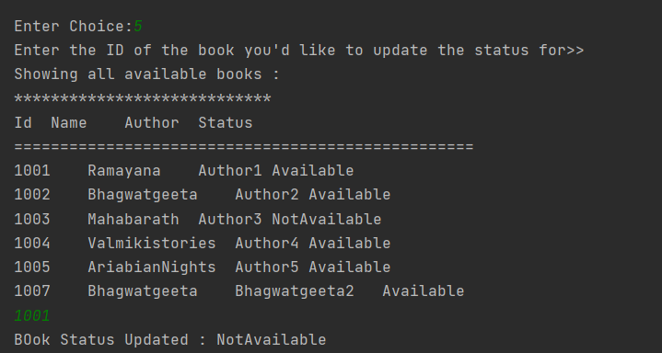

Here we have updated the book status , only done by librarian

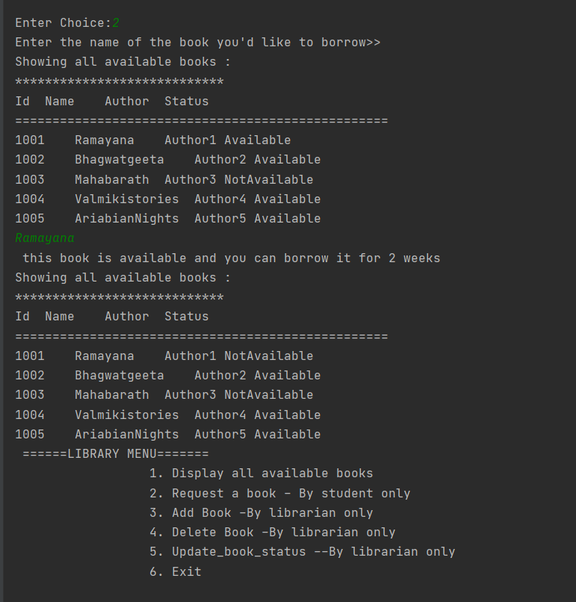

This is accessed by student, he can view and request for a book ., after the book is allotted the status is changed to not available